## Homework #3

Aaron Ge, 11337837

Haotong Sun, 11337172

Danni Weng, 11304053

## Problem 1

## a.

### Result

For Zonal COMED price: 23.678771871299972

For System load forecast: 85295.82107256

For Zonel load forecast : 10067.358660190484

### Interpretation

We are using the optimal lag selected from Assignment 2 to regress our model, and select the last p(optimal lag) observations as our input s, meanwhile utilizing phi from the regression result as input to our function.

For zonal COMED price: The optimal lag is 16, so we use the last 16 observations to do the forecast. The 1-period-ahead forecast is approximately 23.68, which means the expected price for the hour is around 23.68.

For system load forecast: The optimal lag is 3, so we use the last 3 observations to do the forecast. The 1-period-ahead forecast is approximately 85295.82, which means the expected load forecast for the next hour is around 85295.82.

For zonal load forecast: The optimal lag is 5, so we use the last 5 observations to do the forecast. The 1-period-ahead forecast is approximately 10067.3, which means the expected load forecast for the next hour is around 10067.3.

## b.

### Result

For Zonal COMED price:

Estimated coefficients: [ 1.80982889 1.11241998 -0.13615611 -0.09284347 0.03548767 -0.057198

0.00547631 0.04398162 -0.08170224 0.01899361 0.06487121 0.14443145

-0.1586853 0.17512893 -0.20639269 -0.06041851 0.13320543]

Residuals: [ 1.18127577 3.90778336 1.89629594 ... -1.09980742 -0.4743879

0.02216413]

For System load forecast:

Estimated coefficients: [ 2.26734180e+03 2.23678861e+00 -1.71501461e+00 4.53312951e-01]

Residuals: [-296.1429006 306.57411405 561.29016355 ... -552.46223455 -912.12935359

-973.98253603]

For Zonel load forecast:

Estimated coefficients: [ 3.22517794e+02 2.13545815e+00 -1.61897305e+00 6.48358009e-01

-2.75543407e-01 8.23373577e-02]

Residuals: [ 17.47792893 116.68567927 141.99216092 ... -27.09147273 -60.50929364

-244.41268172]

### Interpretation

Still, we are using the optimal lag selected from Assignment 2 to regress our model.

We use full sample to regress the model and generate corresponding phi and residuals from the regression result.

For Zonal COMED price: as our lag is 16, thus the output of estimated coefficients is a 17*1 array(1 interception phi[0], and 16 coefficients); the output of residuals is a 52400*1 array(sample size 52416 exclude 16 lags). The output exactly meets our expectation of function return results.

Similarly, system load forecast and zonel load forecast, whose lags are 3 and 5 respectively, returned coefficients are 4*1 and 6*1 arrays accordingly. The residuals array are 52413*1 and 52411 separately.

## c.

### Result

For Zonal COMED price

array([21.67659698, 18.5825188 , 27.27254048, 26.61531413, 26.9896421 ])

For System load forecast

array([85686.89570415, 83664.33101787, 82191.57759835, 81792.85442923,

83055.12373899])

For Zonel load forecast

array([11109.84138399, 9883.74441347, 9695.74379851, 9707.82423745,

9703.01393435])

### Interpretation

Same, we are using the optimal lag selected from assignment 2.

We didn’t seed the BitGenerator, thus our output may vary every time we run the code.

We are using phi we generate from part b as input of our function

We set h=5, which means our simulation will forecast the next 5 hours value, meanwhile, our function uses the predicted value to predict two or more periods ahead value.

All three of our samples generate outputs as 5*1 array, these are reasonable, as our h=5. We could notice that the 1-period-ahead predictions of the three samples are different from the output of part a. That is because we introduced bootstrapped errors into our simulation.

## d.

### Result

For Zonal COMED price

array([[22.95279088, 16.89783946, 20.65016322, 19.72769583, 24.70607052],

[21.36018916, 26.19606695, 32.42075828, 22.92092645, 25.83562233],

[24.03387659, -4.95734156, 22.37368519, 26.37145856, 29.67710816],

[30.2745214 , 20.14153672, 29.00638851, 29.64161336, 29.6411846 ]])

For System load forecast

array([[84356.65033725, 82004.11924477, 82442.21531973, 81418.87652246,

82960.25629129],

[83461.47928394, 83953.45974766, 84764.57492257, 86899.73619981,

87918.36116852],

[86031.92592898, 89653.00695218, 89874.33261171, 90472.30599856,

91059.03178889],

[89681.02868015, 91368.57570532, 88859.55434855, 89928.79383126,

93209.1917828 ]])

For Zonel load forecast

array([[10368.5429811 , 10043.10218463, 9688.1349473 , 9811.8297492 ,

9825.34696123],

[ 9870.82805662, 10077.66579562, 9881.03772055, 10648.20915975,

10880.83290863],

[10639.27341823, 10981.83532321, 10960.35234019, 10693.81648963,

11144.72280216],

[11093.51803139, 11442.81953444, 11473.55484739, 11722.99806056,

11687.15772134]])

### Interpretation

This function is just slightly different from our function in part c, we simulate the model for N times in this function. We set N=4, which means we simulate 4 times.

As the inputs are slightly different as well, we utilize our function in part b to get the corresponding phi and residuals.

As expected, our outputs are 5*4 arrays. In terms of each sample, each time of simulation generates different results, that’s because we didn’t seed our BitGenerator, each time we simulate the bootstrapped error change, thus the results vary.

## e.

### Result

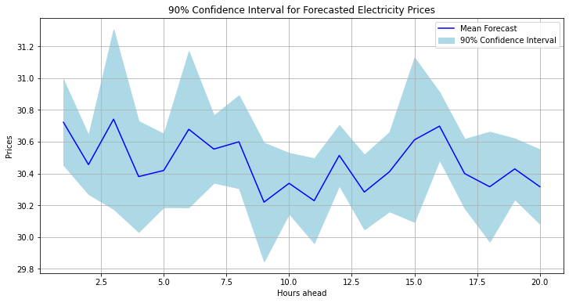

## Problem 2

## a.

### Result

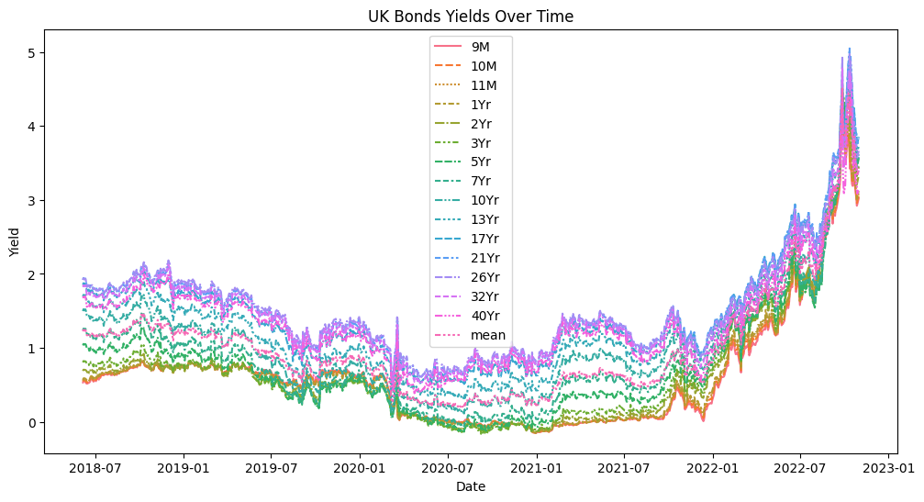

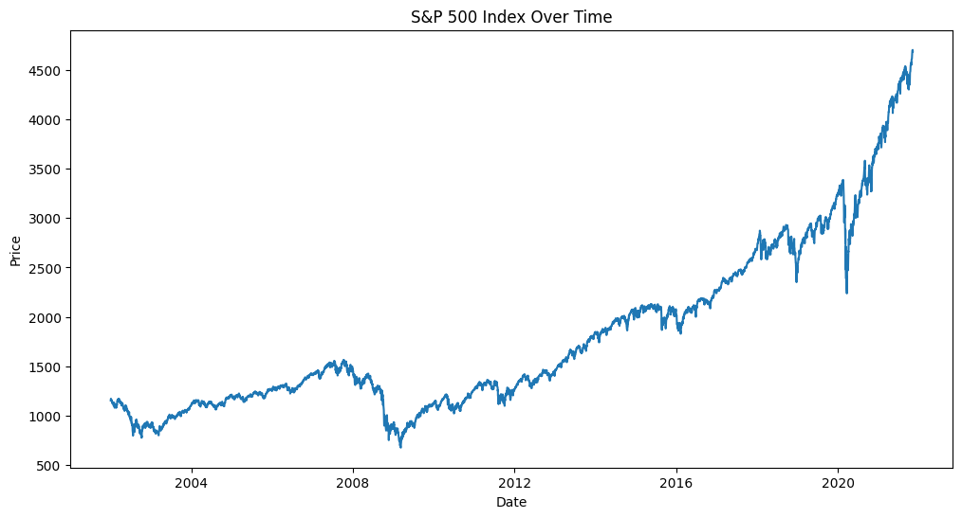

### Interpretation

Descriptive statistics were performed for 1114 data for bonds of different durations and plotted with yield on the vertical axis and time on the horizontal axis. And for each period of the bond to take the average descriptive statistics, get the average yield for 0.998546, standard deviation for 0.737611. from the figure can be seen that the field overall with time to rise.

For the sp500 data, the data were first sorted in chronological order and then descriptive statistics were performed to obtain a mean of 1798.176358 and a standard deviation of std 854.777725. an upward trend over time is clearly observed from the image.

## b.

### Result

ADF Statistics for S&P 500:

ADF t statistic (stationary): 2.7940719079293372

ADF t statistic (trend-stationary): 0.36871262979113933

ADF δ statistic (stationary): -793.8017214552581

ADF δ statistic (trend-stationary): -4440.0982708839365

ADF Statistics for Mean of Bonds:

ADF t statistic (stationary): 1.002721271551447

ADF t statistic (trend-stationary): 0.22624313463674714

ADF δ statistic (stationary): 58.89726418822835

ADF δ statistic (trend-stationary): -5.931970314910625

### Interpretation

For s&p500 the ADF t statistic is 2.7940719079293372, this value is relatively large which means that we cannot reject the original hypothesis i.e. we are not sure that the price is stationary. the smaller the value of ADF t statistic is, the more reason we have to reject the original hypothesis i.e. that the time series is non-stationary. The value of t statistic is 0.37 which is relatively small. Therefore we have a weak reason to reject the original hypothesis that the s&p 500 is trend stable. The value of the δ statistic is -793.80, this value is small meaning that it is possible to reject the original hypothesis that the price is stationary. the value of the trend-stationary is -4440.10, this value is small and we have strong reason to think that the price of the S&P 500 is trend stationary. The S&P 500 price is trend stationary. In conclusion, the price of the S&P 500 may be trend stable, but it is not certain that it is stationary.

The results are similar for the BOND data, with ADF t statistic 1.002721271551447, this value is relatively large meaning that we cannot reject the original hypothesis i.e. we are not sure that the price is stationary. The smaller the value of the ADF t statistic, the more reason we have to reject the original hypothesis.The value of the t statistic is 0.226, this is a relatively small value, therefore we have weak reason to reject the original hypothesis that the s&p500 is trend-stationary. The value of the δ statistic is 58.89726418822835, which is a large value, and therefore it is not possible to reject the original hypothesis that the price is stationary. The value of the trend stationary is -5.931970314910625, which is a relatively small value, and we have weak reason to think that the price of the s&p 500's price is trend stationary. To summarize, bonds may be trend-stationary, but it is not certain that it is stationary.

## c.Result

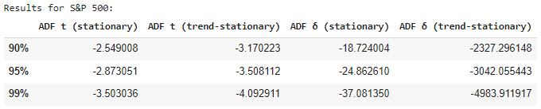

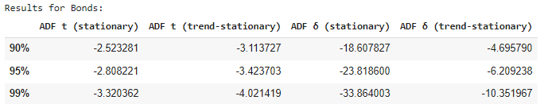

### Interpretation

The ADF test was executed on the data by simulate_and_test function. Each row in the results corresponds to the value of the ADF statistic at different confidence levels.

The values in the 'ADF t (stationary)' and 'ADF t (trend-stationary)' columns indicate the proportion of the simulated time series judged to be stable at the given confidence level. For example, for bonds at a 90% confidence level, the critical value is -2.523281 which means if the t is smaller than -2.523281 we can reject the hypothesis to say it’s non-stationary. Whereas the values of 'ADF δ (stationary)' and 'ADF δ (trend-stationary)' columns are -18.607827 and -4.69579, meaning that if the delta is smaller than these we can reject the hypothesis to say they are non-stationary or trend-stationary .

The results for stocks are similar, under critical value of -2.873051 the series can be considered stationary and under -3.170223 can be considered trend-stationary at the 95% confidence level.At the 1% significance level, the proportion of ADF δ statistic for the trend-stationary hypothesis that is less than the critical value is -18.724004, which implies that about 45.44% of all simulations support that the price of the S&P 500 is on trend-stationary.This is more pronounced than the stock performance

D)

**Estimated critical values of the 4 tests using p = 3, T = 400, N = 500 (SP500 index)**

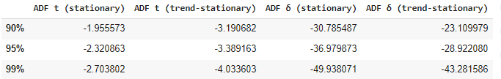

We have used the last 400 observations of the SP500 index to estimate the critical values for our 4 test statistics.

For the ADF t-statistic stationary, the critical values for the last 400 observations are less negative than the autotest results, with differences of approximately 0.59, 0.55, and 0.80 at the 90%, 95%, and 99% confidence levels, respectively. This shift indicates a lower tendency to reject the null hypothesis of a unit root, suggesting that the time series may be more likely to be non-stationary.

The critical values for ADF t-statistic trend have slightly changed, with minor and inconsistent differences. At the 90% level, the critical value became more negative by 0.02, while at the 95% and 99% levels, the values became less negative by 0.12 and 0.06, respectively. This shift is not substantial, indicating that there is no significant change in the tendency to reject the null hypothesis.

For the ADF delta-statistic stationary, the critical values are more negative than the autotest results across all three confidence levels, with differences of approximately 12.06, 12.12, and 12.86, respectively. This shift indicates a higher tendency to reject the null hypothesis of a unit root, suggesting that the time series may be less likely to be non-stationary

Finally, the critical values of the ADF delta-statistic trend stationary are much less negative than the autotest results, which indicates less strict criteria for rejecting the null hypothesis of a unit root. However, our autotest values seem to be unusually large, which may indicate some underlying issues in our calculations.

The observed shifts in critical values could be caused by changes in the underlying properties of the S&P 500 index during the period covered by the last 400 observations. Factors such as changes in volatility, market dynamics, or economic conditions, potentially influenced by the COVID-19 pandemic, could have contributed to these shifts. The recent data may exhibit more characteristics of non-stationarity compared to the earlier period. The data starts right after covid-19 market crash and grows explosively in a short time span.

## E)

## The rolling_adf_analysis function performs a rolling window Augmented Dickey-Fuller (ADF) test on a given time series. It is designed to detect the presence of unit roots, which indicate non-stationarity in the time series. The function takes three arguments: s for time series, p for number of lags, and N for the size of roll and returns a 3 × 4 dataframe with columns corresponding to our 4 test statistics and rows corresponding to the most significant value found for each of your 4 tests statistics and start and end date of window for which those most significant statistics were found.

## F)

**Rolling ADF test on the last 1500 observations of the log SP500 index using p = 3 and N = 250**

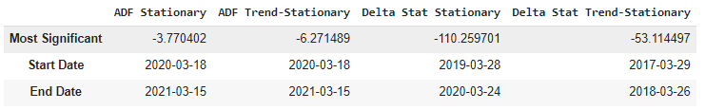

The most significant ADF statistic for stationarity is −3.770402, found in the window from 2020-03-18 to 2021-03-15.

The most significant ADF statistic for trend-stationarity is −6.271489, found in the window from 2020-03-18 to 2021-03-15.

The most significant delta statistic for stationarity is −110.259701, found in the window from 2019-03-28 to 2020-03-24.

The most significant delta statistic for trend-stationarity is −53.114497, found in the window from 2017-03-29 to 2018-03-26.

The strongest rejection of the unit root null hypothesis is found in the ADF Trend-Stationary test statistic, which has a value of -6.271489. This rejection occurred in the rolling window from 2020-03-18 to 2021-03-15. This suggests that during this period, the log of the S&P 500 index was trend-stationary, indicating a strong rejection of the presence of a unit root.

Based on our results, the US stock market, represented by the S&P 500 index, can sometimes be I(0), meaning it can exhibit stationary behavior. This is particularly evident during the period from 2020-03-18 to 2021-03-15, where the ADF Trend-Stationary test statistic strongly rejects the unit root null hypothesis. However, this does not imply that the market is always stationary; rather, it may exhibit stationary behavior during certain periods. No test Overall, the stock market is non-stationary as it has historically trended upward (long run).

## Problem 3

### True

The test statistic of the forecast error would help to determine the efficacy of the forecast model. That is the crucial reference to see the model’s performance. The Diebold-Mariano (DM) test is indeed one of the practices used to evaluate the performance of forecasting models, the test statistic helps to determine if one model significantly outperforms the other.

### False

There is no best method for balancing the bias-variance tradeoff, the best method always depends on the characteristics of the data we have. Sometimes might involve a combination of different methods.

### False

Parametric regressions do not always decrease variance. Parametric regression relies on the assumption of data distribution. If the assumptions are incorrect, it can increase variance.

### True

The PP test does not reject H0, but the KPSS does. In this case, we conclude that the series is I(1)